Dates for Diary:  Thursday 18 July  10:30: Finance Budget Working Party  Saturday 20 July 10 am : PCC & DCC Away Day at Littleover Methodist Church  Monday 22 July 10 am : PCC & DCC Meeting | Ministry Team:  Team Rector: Revd Andy Ward  T: 760846 / M: 07860 418915  rector.walbrook@gmail.com  St Thomas’ Community Minister:  Revd Dr Simon Cartwright  T: 07720 769631; revscartwright@gmail.com  Curate: Revd Sarah Watson  T: 07539 430884; curate.walbrook@gmail.com  Reader [Lay Minister]:  Ms Louisa Wass Griffiths  M: 07968 624382; l.wass@btinternet.com  Operations Manager: Mrs Sonia Robinson  M: 07812 537015. Office contact details below
Finance
At St. Augustine’s we do not pass round an offertory plate during services. Instead a plate is provided in the welcome area for those who would like to make donations. Please bear in mind that the work & upkeep of this church are funded entirely by the giving of the regular congregation & donations. If you would like to give regularly by Parish Giving Scheme or by other ways, please contact Sonia Robinson, Operations Manager, on 270837 or email office@staugustinesderby.org. If you’re giving is to St. Thomas’ Community, please contact Jo Simister on 01332 367690. Thank you.
Safeguarding
We have a Safeguarding Policy in place which is available to view on request. For details of what to do if you have a concern, see the procedure displayed on the notice boards.
Contact safeguarding lead on
Tel: 07518 142 346
Parish Office
Normal Opening Hours:
Monday to Thursday: 9am-2pm;
Fridays: closed.
St Augustine’s Church
Upper Dale Road Derby DE23 8BP
Tel 270837
email: office@staugustinesderby.org
Operations Manager: Sonia Robinson

Children and young people are very welcome and will be in for all the service today

Parents are responsible for their children whilst they are in the service

find us on facebook:
St Augustine’s Church Derby
https://www.facebook.com/groups/
113262952065247/
St Thomas Derby: Journeying Together https://www.facebook.com/StThomasDerby/

St. Augustine’s Church and St. Thomas’ Community is part of the Parish of Walbrook Epiphany incorporating the districts of St. Augustine, St. Chad, St. James and St. Thomas

Welcome to

St Augustine’s CHURCH & St. Thomas’ COMMUNITY

a loving community following
Jesus and serving Normanton

Sunday 30 The Second Sunday after Trinity

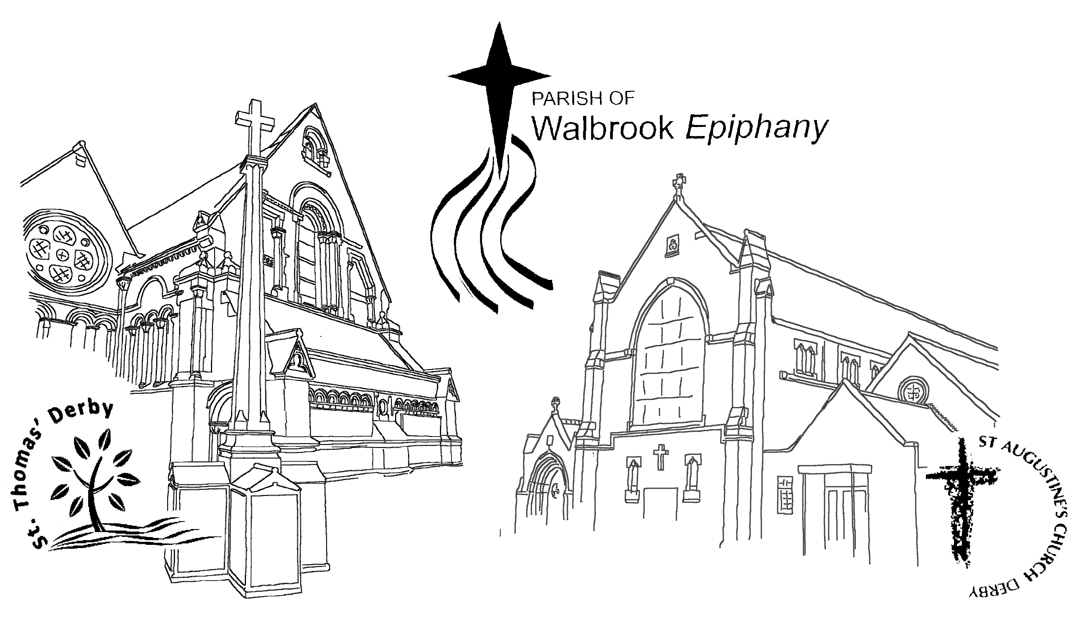

Children and young people are also very welcome
and will be in for all the service today

PRAYERS FOR TODAY:
Collect: Faithful Creator, whose mercy never fails: deepen our faithfulness to you and to your living Word, Jesus Christ our Lord.

Post Communion:
Loving Father, we thank you for feeding us at the supper of your Son: sustain us with your Spirit, that we may serve you here on earth until our joy is complete in heaven, and we share in the eternal banquet with Jesus Christ our Lord.

Anthony and Dawn’s Ordination
Will be at the Cathedral on Sunday 30 June at 10:30am. Followed by a welcome meal and service at St. Thomas at 4 pm. You are all invited

Hymns & Songs at St. Augustine’s:

766 - Thou didst leave thy throne
454 - Lord, for the years

Readings at St. Augustine’s: Galatians 5:1, 13 – 25 & Luke 9:51 - 62

St. Thomas’ Community
You are invited to join us at 5 pm tonight for evening prayer at St. Thomas’ Church, Pear Tree Road, Derby, DE23 8NQ. Find us on facebook: St. Thomas Derby – Journeying Together. Email: derbystthomas@gmail.com Vicar: Revd Dr Simon Cartwright: Tel: 01332 36769
Huddle Groups
Would you find it helpful to meet in a small mid-week group, where you can chat about the joys and challenges of being a Christian in every day life? The group conversations centre around questions like “What is God saying to you?”, “What are you doing in response?” and ‘How is this building faith in you?”. We’ll be learning some helpful discipleship tools too (called Life shapes) for helping spiritual health and growth. Huddle Groups are by invitation only, but if you’d like to find out more and register an interest in joining a group starting in September, please speak to Andy, Louisa or Sarah by Sunday 18th August latest. Our Huddles usually meet fortnightly Sept - July each year, and can be offered in daytime or evening. Thanks.
Hymn and Song Repertoire

We have decided that with effect from September we’ll introduce a new way of choosing hymns and songs which will mean everyone has chance to suggest what we will sing. The plan is that once a year we’ll invite everyone who would like to to suggest hymns and songs that they would like us to use, and then we’ll include them in the repertoire service leaders chooses from when planning each service.
So, here’s your chance! If you would like to suggest things for us to sing in our worship, please send them to the Parish Office either by email or on paper by Sunday 28th July. We will then draw up a repertoire for use from the beginning of September.
At this point we express our thanks to the team of people who have been choosing the hymns for Gussies’ morning service up until now - thank you!
Monthly Thursday Communion & Lunch – Sunday 4 July
On Thursday 04th July at 12:30pm you are invited to our midweek Communion Service followed by a light lunch.
Summer Open House – Saturday 6 July
You are welcome with your family and friends to come to our Summer Open House(BBQ). On Saturday 6th July 2019 between 5:30 pm and 8:00 pm. Where: YWAM Derby 96 Whitaker Road DE23 6AP Derby. To register: Call or Text 07897583153.

Summer BBQ for Families Involved in Fostering and Adoption – Sunday 14th July(4 pm to 6 pm)
If you are in the Derby area and your family, or a family you know, is involved in fostering and adoption, this is an opportunity for the whole family to get together with other families also involved. For more information please contact Andy Ward on 07860 418915. If you can’t make the BBQ but are interested in being invited to any future events please do get in touch to register your interest.
Important Information:
Sonia will be away now until Monday 15 July. Andy will be on retreat however if you need to contact the Parish Office urgently please text Andy and he will get back to you as soon as he is able to. If you have any items for the Information Sheet please email Caio on caio.staugustinesderby@outlook.com by Wednesday of each week.

